**Lake Toba, North Sumatra - Largest Caldera**

A gorgeous view of Lake Toba

Image Source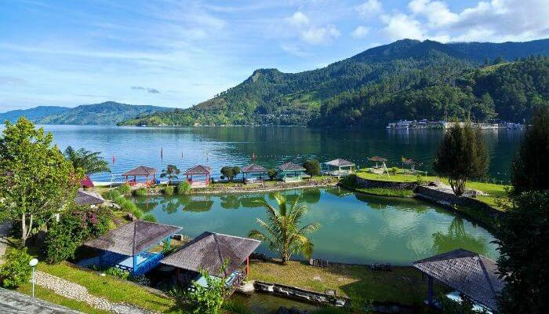

Lake Toba, situated on Earth's largest caldera, has a volcanic origin and was formed approximately 70,000 years ago. It may sound like a riddle but Lake Toba is situated on an island, which again is in a lake! If you didn't get it, read again. It is indeed one of the popular Indonesia tourist places in the whole world.

Tips: The climate at Lake Toba gets cold. Keeping woolen clothing with you should come in handy.

Things to do: Swim in the volcanically warmed water. Besides, it is perfect to relax and enjoy the stunning surroundings of this beautiful place in Indonesia.

Best places to stay: Hotel Carolina, Toledo Inn, and Hotel Tiara Bunga.

Tourist Attractions: Air Terjun Sipiso Piso, Bukit Indah Simarjarunjung, Pasir Putih Parbaba, Bukit Holbung Samosir

Places To Eat: Rumba Restaurant, Maruba Restaurant, Jenny's

Best Time To Visit: May and September

How To Reach: Medan is an international gateway. Parapat, the town by Lake Toba, is 176 km away from Medan and can be reached in under 6 hours by public buses that follow two routes: Medan-Parapat or via Medan-Berastagi.

**Soal narrative text “The story of Toba Lake”**

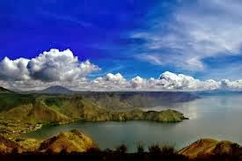

Once upon a time, there was a man who was living in north Sumatra. He lived in a simple hut in a farming field. He did some gardening and fishing for his daily life.

One day, while the man was do fishing, he caught a big golden fish in his trap. It was the biggest catch which he ever had in his life. Surprisingly, this fish turned into a beautiful princess. He felt in love with her and proposed her to be his wife. She said; “Yes, but you have to promise not to tell anyone about the secret that I was once a fish, otherwise there will be a huge disaster”. The man made the deal and they got married, lived happily and had a daughter.

Few years later, his daughter would help bringing lunch to her father out in the fields. One day, his daughter was so hungry and she ate his father’s lunch. Unfortunately, he found out and got furious, and shouted; “You damned daughter of a fish”. The daughter ran home and asked her mother. The mother started crying, felt sad that her husband had broken his promise.

Then she told her daughter to run up the hills because a huge disaster was about to come. When her daughter left, she prayed. Soon there was a big earthquake followed by non-stop pouring rain. The whole area got flooded and became Toba Lake. She turned into a fish again and the man became the island of Samosir.

Based on the Text above, please choose the best answer by giving the cross mark in the letter

T if the statement is true and the letter F is the statement is false.

1. T – F The golden fish turned into a beautiful woman.

2. T – F The man and his wife lived happily forever.

3. T – F The man had broken his promise.

4. T – F His daughter turned into a fish.

Based on the Text above, please answer the questions by choosing and giving the cross mark to the best answer according to you. (for questions number 5 – 8)

5. What is the complication in paragraph 3?

A. The mother started crying, felt sad that her husband had broken his promise.

B. His daughter would help bringing lunch to her father out in the fields.

C. His daughter was so hungry and she ate his father’s lunch.

D. The daughter ran home and asked her mother.

E. The man shouted and be furious.

6. Finally, what did happen to the man?

A. He sunk

B. He turned into a lake

C. He turned into a fish

D. He turned into an island

E. He attacked by earthquake

7. What can we learn from the text above?

A. We must obey our parents

B. We must not break our promise

C. We must not eat our father’s meal

D. We must go fishing to find a golden fish

E. We must run to the hill if there is earthquake

8. What is the best title of the text above?

A. Toba lake and Samosir in North Sumatera

B. The man, the fish and their daughter

C. The story of Samosir island

D. The man and the gold fish

E. The story of Toba Lake

Based on the Text above, please answer the questions below! (for questions number 9-11)

9. What is the resolution of the second paragraph? (Point 4)

10. Why did the mother feel sad and start crying? (Point 4)